**DATA ANALYTICS**

**EXTERNSHIP PROGRAM**

**MANU PRADEEP KUMAR**

**20BRS1051**

**ASSIGNMENT -1**

**1) Download tableau desktop & Mysql in your PC or laptop**

**2) Create a new schema in your Mysql workbench and upload your data**

**3) Connect your Mysql and Tableau**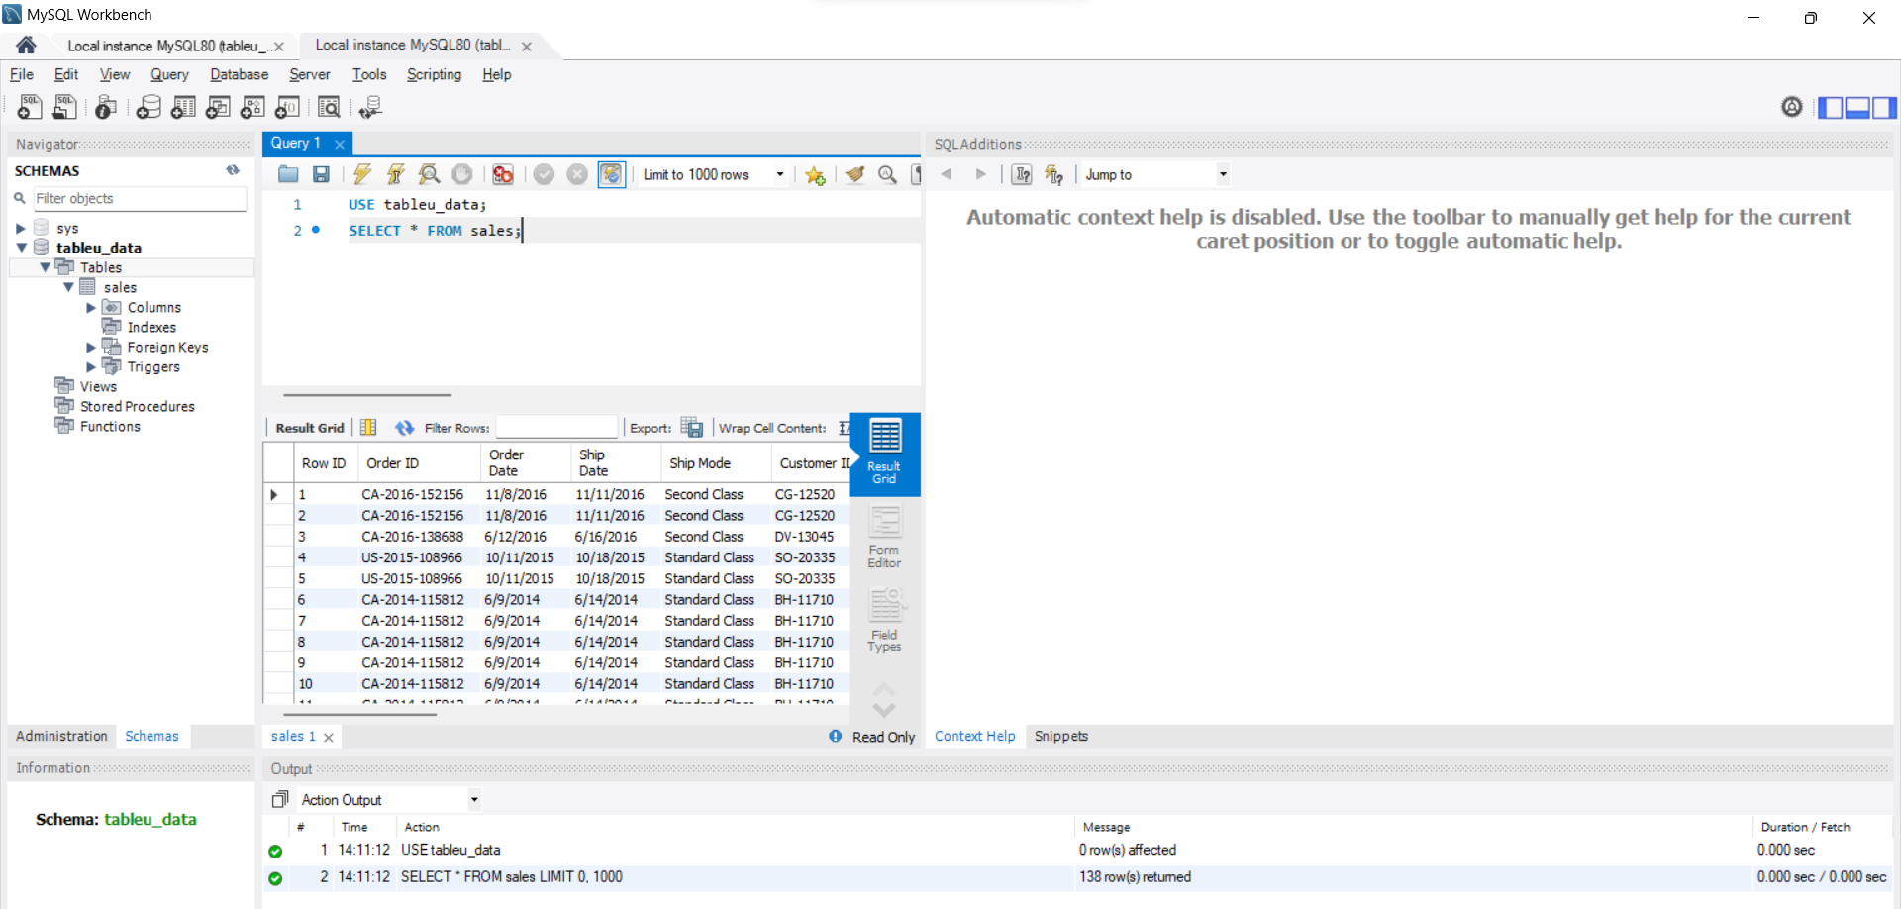

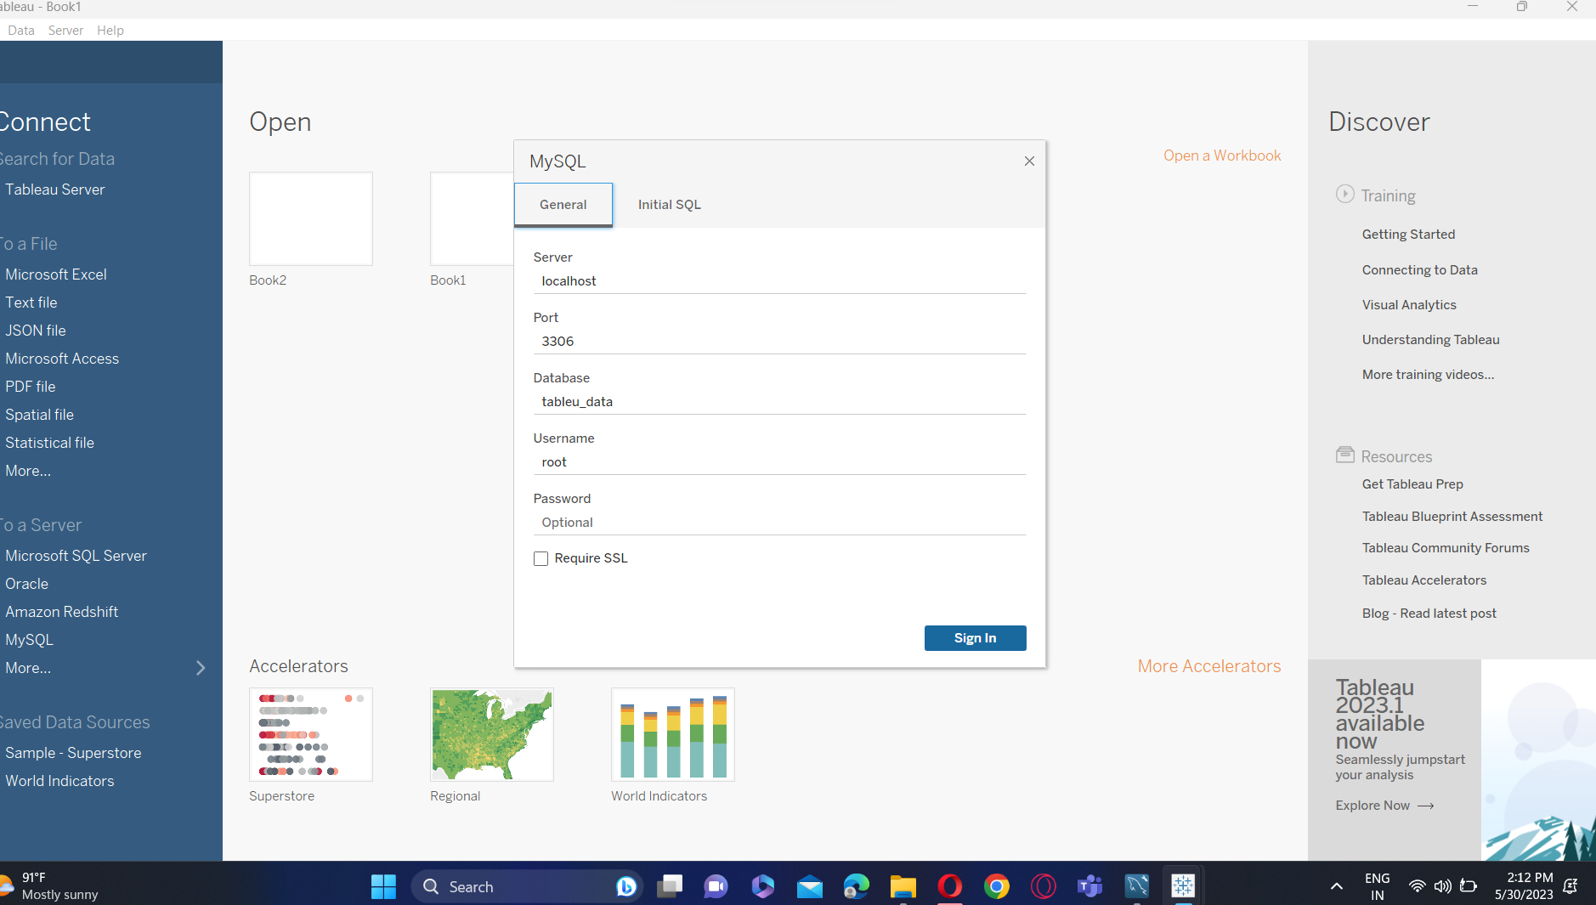

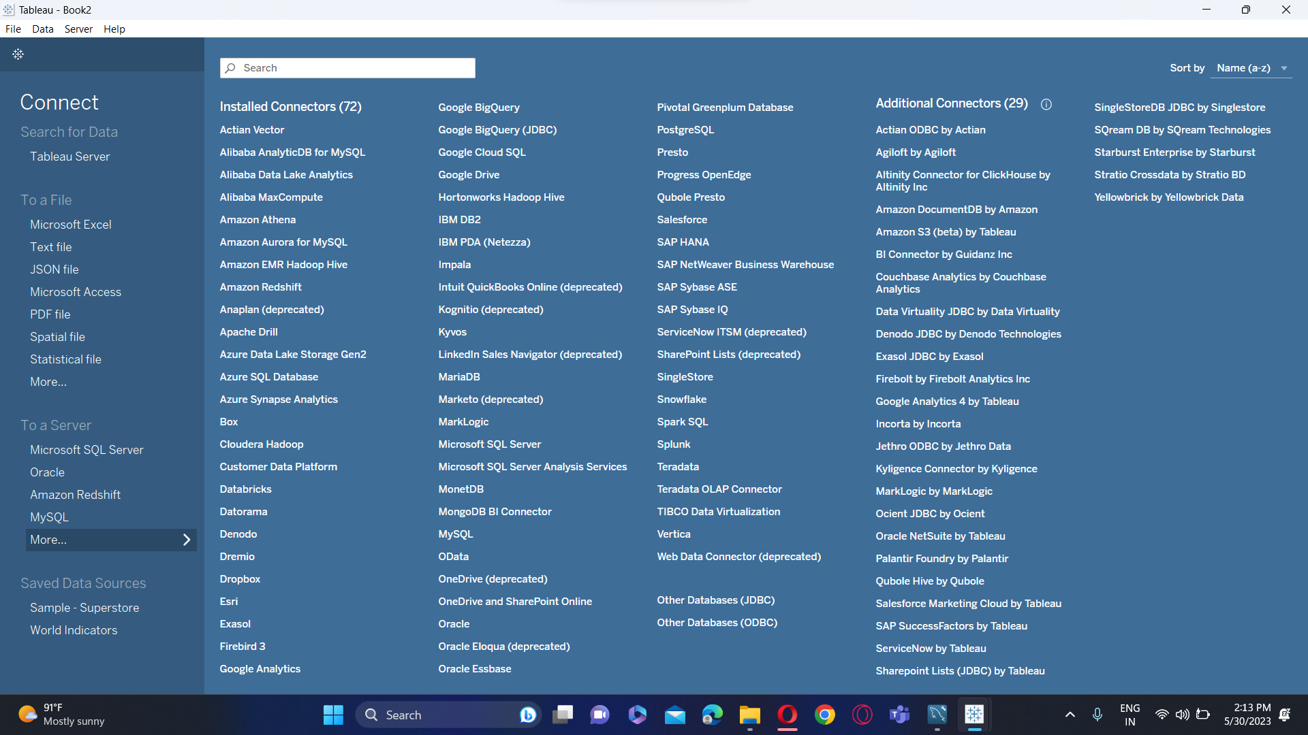

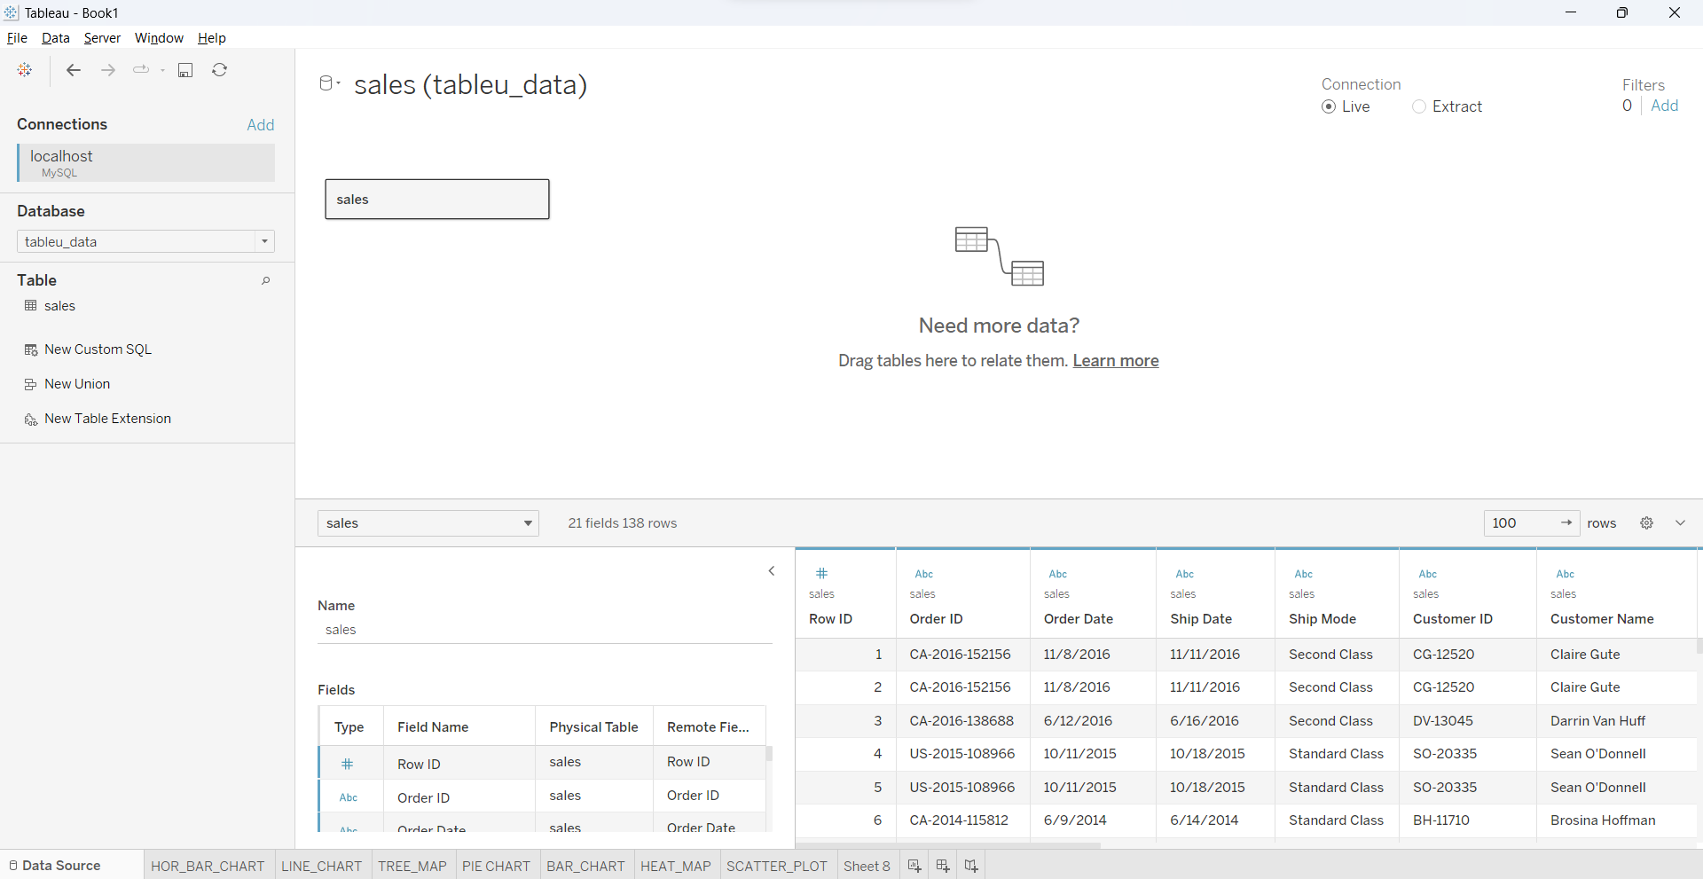

**4) Create the below 5 charts/plots**

**● Bar chart**

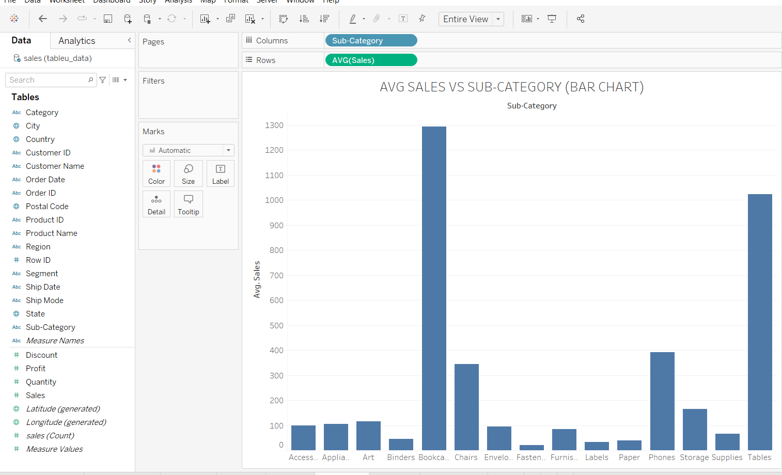

**● Tree map**

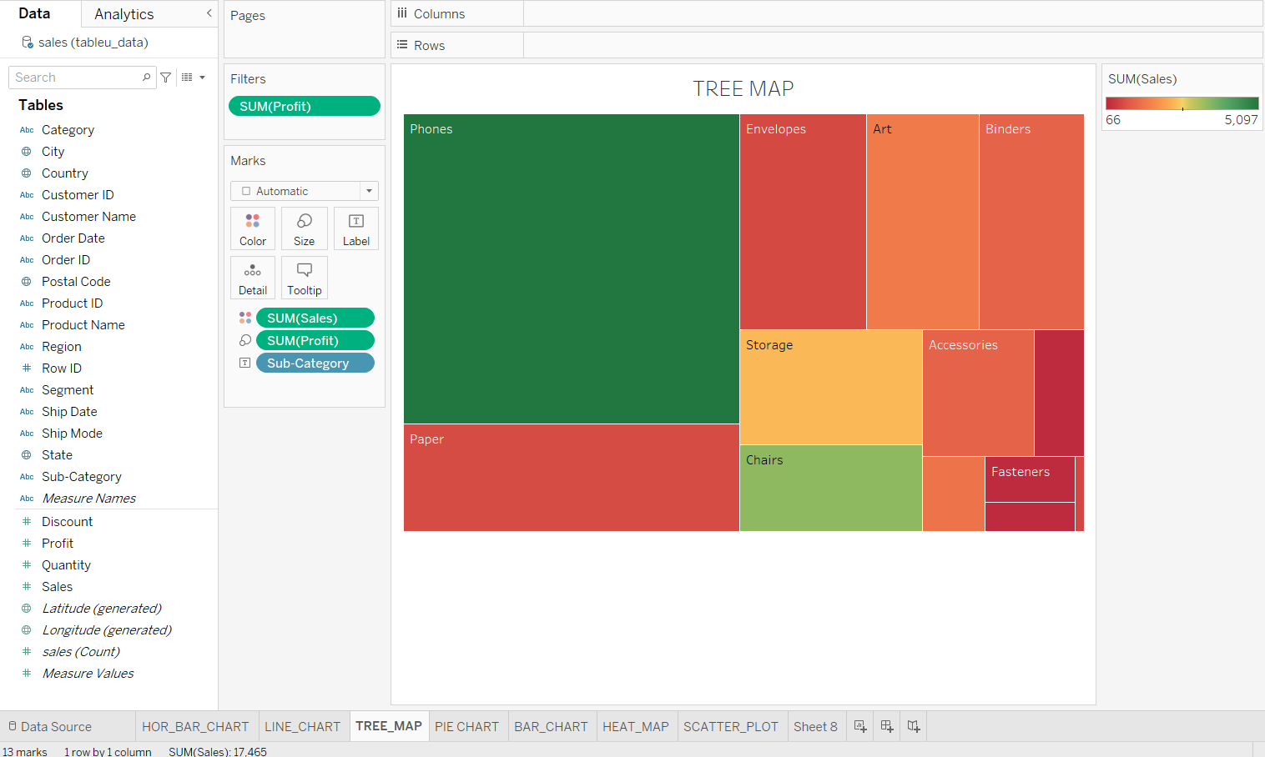

**● Heatmap**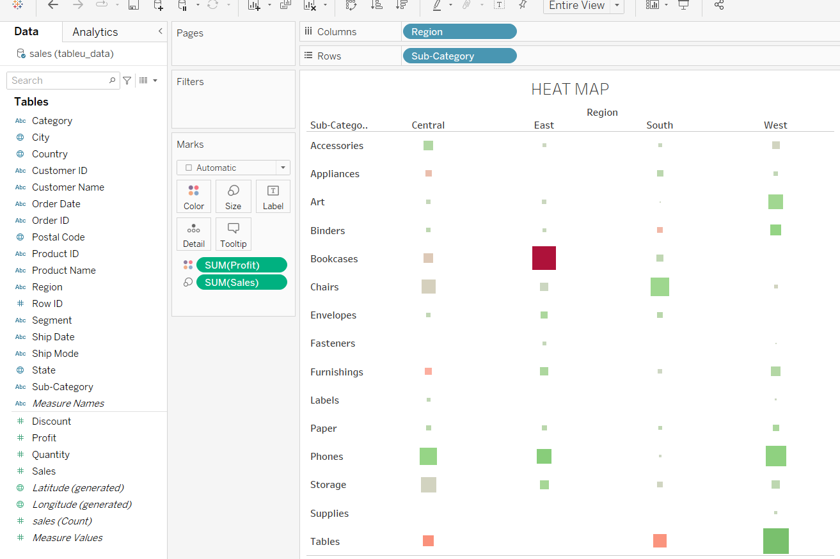

**● Pie chart** 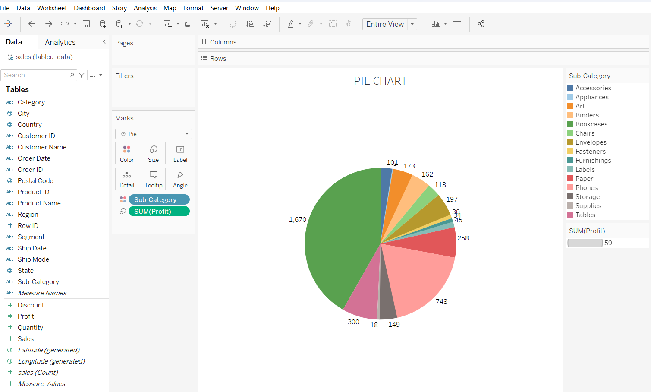

**● Horizontal bar chart**

